DRIVING thru the BIBLE

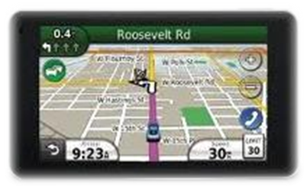

12 Areas of Judgment for Christians

- How we treat other believers Heb 6:10; Matt 10:41-42

- How we exercise our authority over others Heb 13:7; James 3:13

- How we employ our God given abilities 1 Cor 12:4, 11:2; 2 Tim 1:6; 1 Pet 4:10

- How we use our money 1 Cor 16:2; 2 Cor 9:6-7; 1 Tim 6:17-19

- How we spend our time Ps 90:12; Eph 5:16; Col 4:5; 1 Pet 1:17

- How much we suffer for Jesus Matt 5:11-12; Mark 10:29-30; Rom 8:18; 2 Cor 4:17; 1 Pet 4: 12-13

- How well we run that particular race which God has chosen for us 1 Cor 9:24; Phil 2:16, 3:13-14; Heb 12:1

- How effectively we control the old nature 1 Cor 9:25-27

- How many souls we witness to and win to Christ Prov 11:30; Dan 12:3; 1 Thess 2:19-20

- How we react to temptation James 1:2-3; Rev 2:10

- How much the doctrine of the Rapture means to us 2 Tim 4:8-9

- How faithful we are to the word of God and the flock of God Acts 20:26-28; 2 Tim 4:1-2; 1 Pet 5:2-4

Caution!!

The 12 areas listed above are rewards for activities lead by the Holy Spirit… do not get into a “works” mentality of “I’m doing these things for God… boy is He gonna’ be proud of me for helping Him out!!”

