DRIVING thru the BIBLE

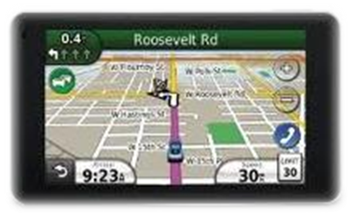

The Parable of the A-I-R-B-A-G
After - Internalizing - Redemption - you can Begin - to let Anxiety - Go
You look up ahead and you notice that the traffic begins to slow. You’re not sure yet what has caused the slow down, but you know that something is wrong. You drive this highway often and there is seldom a traffic jam in this area of the highway this time of day. You then notice a couple cars pull off onto the shoulder of the road. The traffic then stops. A few minutes go by … a highway patrol car comes to the scene, followed by an ambulance. It must be serious.
The traffic then starts to move ahead slowly. As you pass the scene of the accident, you can see that a pickup truck has been rear ended by a new sedan. It’s a mess … broken glass, liquid on the pavement, bent metal. Everyone is anxious about the situation. Emergency personnel are removing the driver of the sedan. You roll down your window and ask if you can help. “Nope,” says an emergency team member, “It’s just a scratch. The airbag did its job. It probably saved the drivers life!
The driver of that car will never forget how that airbag saved their life. They will probably tell everyone about the day they were just driving along, and all of a sudden, they slammed on their brakes and ran into the back of a pick up truck. Sadly, a similar situation can occur in our spiritual lives. We are out driving on the road of life everyday. And Satan has no problem slamming on the brakes in front us and causing us to get off track. His actions are very much like the current car insurance fraud scheme where one driver pulls in front of you and slows down quickly to cause you to rear end them. Satan knows that without the protection Christ, of our spiritual airbag, we are just one severe accident away from losing out on Christ’s offer of salvation.
If the apostle Paul had been living today and describing the armor of God in an Epistle to the Americans, he surely would have included the airbag in his list of protective devices because of the number of miles we drive everyday. So don’t delay. Give your heart to Christ and receive one more piece of “armor” to help take away the anxiety when driving the road of life (Ephesians 6:10-18). Sign up today for your spiritual…
A-I-R-B-A-G
After - Internalizing - Redemption - you can Begin - to let Anxiety - Go

