DRIVING thru the BIBLE

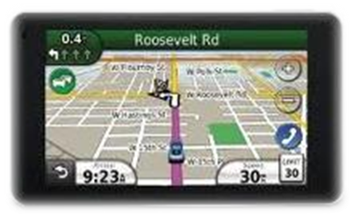

The Parable of the two A-X-L-E Trailer

Always - eXercise - Love - Exclusively

Most of us in the motorsports world are familiar with trailers. There’s the single axle trailer that’s used to haul lighter motorsports toys such as a small boat for water skiing or bass fishing on a lake. You can also use a single axle trailer to strap down a couple quads or a motorcycle for a weekend trip to the desert. Or you might want to use a single axle trailer to transport a lighter car and a few small tools to the local drag strip.

But when our toys get bigger and heavier, our trailer must also get bigger and stronger to carry the heavier load. That’s when we move up to the two-axle trailer. A standard open or enclosed two-axle trailer can easily carry a modern racecar and all the extra fuel, tires, and accessories necessary to service the car at the track. The current favorite among younger families that participate regularly in motorsports events is the two-axle “toy” hauler. Not only can you bring along all the toys and accessories needed for a racing weekend 300 miles away from home, you can also cook meals and watch TV while you are there, and then sleep in a real camper type bed when the kids pass out in their sleeping bags from eating too many hot dogs!

A similar concept is used in our witnessing life. When we accept Christ as our Lord and Savior, we are commanded to take part in what is known as the Great Commission: “Therefore go and make disciples of all nations, baptizing them in the name of the Father and of the Son and of the Holy Spirit (Matt 28:19). And because we are never sure where this new witnessing commission will take us, we need to build our gifts on something that will support our witnessing load no matter where we are called to go. The two “spiritual” axles that Christ wants us to build our lives upon can be found in the two Great Commandments: “'Love the Lord your God with all your heart and with all your soul and with all your mind.' This is the first and greatest commandment (axle one). And the second is like it: 'Love your neighbor as yourself' (axle two)" emphasis mine (Matthew 22:37-39).

So the next time you have a chance to witness to someone, just remember that your Lord and Savior has provided you with a special two-AXLE witnessing rig that will support you and your gifts wherever He leads you to carry out the Great Commission. So load up your gifts in Christ’s Two-AXLE “Joy” Hauler, and when you witness as part of the Great Commission:

A-X-L-E

Always - eXercise - Love - Exclusively!

