DRIVING thru the BIBLE

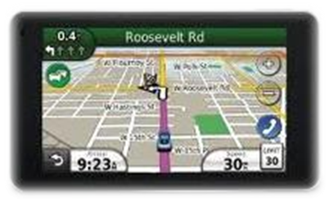

The Book of Acts - Peter and Paul Parallels

Chapters 1 - 12 Chapters 13 - 28

Jerusalem is the center Antioch is the center

Peter is the Chief figure Paul is the Chief figure

Word goes out to Samaria Word goes out to Rome

Word rejected by Jews of the homeland Word rejected by Jews of the Dispersion

Peter imprisoned Paul imprisoned

Judgment on Herod Judgment on the Jews

Peter’s Ministry Paul’s Ministry

First Sermon 2 First Sermon 13

Lame man healed 3 Lame man healed 14

Simon the Sorcerer 8 Elymas the Sorcerer 13

Influence of his shadow 5 Influence of a handkerchief 19

Laying on of hands 8 Laying on of hands 19

Peter is worshipped 10 Paul is worshipped 14

Tabitha raised from dead 9 Eulychus raised from dead 20

Peter imprisoned 12 Paul imprisoned 28

