DRIVING thru the BIBLE

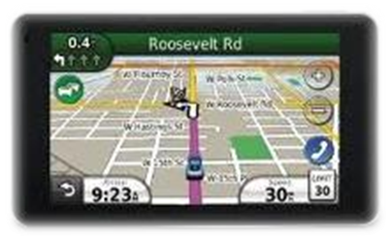

Advice from an Old Farmer

- Life is simpler when you plow around stumps

- A bumble bee is considerably faster than a John Deere tractor

- Words that soak into your ears are whispered… not yelled

- Meanness just don’t happen overnight

- Forgive your enemies… it messes up their heads

- Don’t corner something that is meaner than you

- It don’t take a very big person to carry a grudge

- You can’t unsay a cruel word

- Every path has a few puddles

- When you wallow with pigs, expect to get dirty

- The best sermons are lived, not preached

- Most of the stuff people worry about ain’t gonna’ happen anyway

- Don’t judge folks by their relatives

- Remember that silence is sometimes the best answer

15. Sometimes you get, and sometimes you get got

16. Your biggest troublemaker might be the person that looks back at you in the mirror

17. Always drink upstream from the herd

18. Good judgment comes from experience, a lotta’ that comes from bad judgment

