DRIVING thru the BIBLE

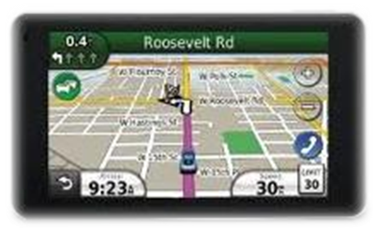

The Parable of the Engine B-E-L-T

Become - Encircled - by Love - and Trust

I can remember walking into an auto parts store back in the early 1960’s and asking for something know simply as a “fan” belt. There would be two dozen or so “fan” belts hanging there on the wall behind the parts counter. The parts clerk would say something like, “You need one for a 53 or a 54 Chevy?” If the clerk had one in stock, you usually asked him for two … one to install on the engine, and one to put in the trunk. You never wanted to be on a long trip without a spare “fan” belt, especially if you were lucky enough to have power steering!

Well today the fan belt has been replaced by something called an engine belt. The newer belt is much wider than the older belts, and it has several deep groves on the inner side rather than just the one “wedge” shaped side that fit into just two or three single groove pulleys found on older engines. The newer belts also operate pulleys and idlers from “both” sides of the belt. And when you have one of these newer belts replaced, the modern day mechanic must be double jointed in both his fingers and wrists and have elbows that operate backwards like flamingos knees!

But whether you had one belt operating three pulleys, or a newer two-inch belt operating seven or eight pulleys from both sides of the belt, whenever the belt broke, you were soon to be on the side of the road waiting for help.

When we accept Christ’s offer to become our Lord and Savior, He encircles us in His Love and Trust, much like a fan or engine belt encircles pulleys or idlers. He starts us out with that basic fan belt until we learn to trust Him enough to not keep looking in our spiritual trunk to see if we have a spare belt just in case He leaves us. Then as we mature in our Christian walk, and trust Him with more areas and gifts within our life, He increases the width of the belt allowing Him to now operate more gifts on both sides of the belt.

But no matter where we are on His engine belt maturity scale, there’s one thing we no longer have to worry about: He has promised to never leave us or forsake us on the side of the road of life (Hebrews 13:5). Even when our spiritual belt squeaks and smells like it may give way at any minute, He steps in and makes the necessary adjustments to get our gifts once again operating as a unit.

So stop looking in your spiritual trunk for the spare belt… give your heart to Christ and start wearing the belt that never wears out:

B-E-L-T

Become - Encircled - in Love - and Trust

