DRIVING thru the BIBLE

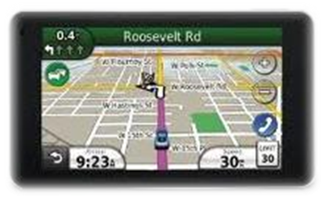

The Parable about B-L-I-N-G

Believers - Learn - It (stuff) is - Not - God

Well here they come down the red carpet … the usual suspects from the entertainment world, dressed to kill, and wearing lots of expensive clothing and jewelry. As they move down the red carpet toward the theatre entrance, they stop by for the obligatory interview. “My, what a beautiful diamond necklace you’re wearing tonight. Where is it from?” asks the young interviewer. “Oh … it’s from so-n-so jewelers here in LA … it’s on loan tonight for the festivities,” says the young starlet. “We’re all dying to know how much they cost,” ask the interviewer. “5 million dollars,” says the starlet!

Shaking your head at such superficial behavior, you quickly turn the TV channel to watch the latest hot rod show and car auction, a much more manly and sane activity. Now up for bids is the final car for the evening: a beautifully restored 1967, 427/435hp Marina Blue Corvette Roadster. The original price sticker for this Corvette from 1967 is: $4,219.25, plus $1,125.00 for factory installed options and accessories … total sales price in 1967: $5,344.55. The TV announcer reports that earlier bidding for this rare muscle car had been fierce. But the bidding has now come down to just two; one guy is bidding in the audience, and one guy is bidding by phone. The guy bidding in the audience suddenly throws up his hands and indicates that he is done bidding. The auctioneer raises his gavel and utters those familiar words before the bidding ends, “Going once, going twice, sold to the man on the telephone … for $215,000.00.

Christ also talked about living the “abundant” life with the Jewish leaders of His day. When they asked Him why He came to earth, He said, “I am the gate; whoever enters through me will be saved. He will come in and go out, and find pasture. The thief comes only to steal and kill and destroy. I have come that they may have life, and have it more abundantly” (John 10:9-10). In this scripture, Christ did not mean when using the word “abundance” that He came to make us all rich in the eyes of this world. His point was that an abundant life in this world was the knowledge that we would one day be with Him in the next world, and that the greatest joy while we were still here in this world would be to live a life of service and give Him all the glory whenever possible.

Satan and his fellow travelers, on the other hand, promise us that if we will just gather enough flashy and glitzy stuff, “bling,” then we will finally be happy and satisfied. I bought into that lie as a younger man, trying to impress others by accumulating stuff. But I learned over time that having a lot of stuff did not lead to happiness. It was empty; and when the “bling” left, so did most of the crowd.

So if you want to live a more “abundant” life here on earth, ask Christ to become your Lord and Savior. You’ll soon learn what most believers have learned about:

B-L-I-N-G

Believers - Learn - It (stuff) is - Not - GOD!

