DRIVING thru the BIBLE

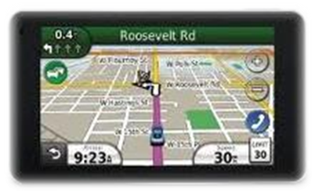

The Parable of the Burn OUT

Burn - Outdated - Unclean - Thoughts

A drag race pits two vehicles against each other over a straight measured distance from a standing start. Before each race (also known as a "pass"), each driver is allowed to perform a burnout (which heats the tires and lays rubber down at the beginning of the track, improving traction), then lines up (or "stages") at the starting line. And because the car has travelled down the track a short distance beyond the starting line during the burn out run, the driver must shift the car in reverse and then back up slowly to the staging lanes before the cars are called forward to the starting line.

But not all the burned rubber sticks to the track during burn out. Some small chunks of rubber stick to the hot tire surface and must be removed from the tire surface before the drag race. This rubber debris removal process is performed by race crew personnel when the car is backing up to the staging lane area after the burn out. A crew member on each side of the car “wipes” and “pulls” the rubber debris off the tire as the car backs into the staging lane area. If this debris cleaning process is not complete, the tire surface might not fully engage the track surface when the car leaves the starting line.

The same sort of thing can happen when we travel the always hot and sticky roads of life. Just like the hot tires on the dragster can pick up hazardous debris during burn out, we too are exposed to hazardous worldly debris that can just as easily get stuck to our “spiritual” tires. And if we are not in regular communication with our Lord and savior through prayer, we risk the same loss of traction in our spiritual life as the dragster does during a drag race. The Holy Spirit was sent to the church on the day of Pentecost for this very purpose (worldly hazardous debris management!). When we give our heart to Christ, the Holy Spirit within us prompts us to make the necessary adjustments so that we can maintain maximum spiritual traction. The apostle Paul tells us in 2 Corinthians 6:17-18, "Therefore come out from them and be separate, says the Lord. Touch no unclean thing, and I will receive you. I will be a Father to you, and you will be my sons and daughters, says the Lord Almighty."

So the next time you go to the Lord in prayer, ask Him to help you perform a spiritual:

Burn O-U-T

Burn - Outdated - Unclean - Thoughts

