DRIVING thru the BIBLE

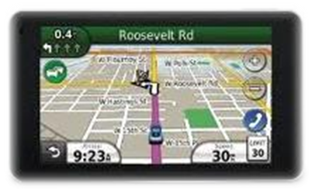

Church Signs (Humor)

He who kneels before God can stand before anyone

Psalms read here

The will of God will never take you where the Grace of God cannot protect you!

Sorrow looks back… Fear looks around… Faith looks up

The best vitamin for a Christian is to B1

Coincidence is when God chooses to remain anonymous

Under the same management for over 2,000 years

Peace on the outside comes from knowing God on the inside

Looking for a lifeguard… ours walks on water!

Worry is interest paid on trouble before it’s due

Character is how you treat those who can do nothing for you

Trade God your pieces for His peace

If the truth hurts, then it’s working

You make the choice… God makes the change

No man is rich enough to buy back his past

Keep your words sweet… you may have to eat them one day

Exercise Daily: Walk with the Lord and run from Satan

Purity of your soul can’t be lost without your approval

It’s risky to go out on a limb… but that is where the fruit is

The best way to get even is to forgive and forget

The heaviest thing you carry is a grudge

Those who follow the crowd are usually lost in it

To belittle is to be little

Practice makes perfect… so be careful what you practice!

If God brings you to it, He will bring you through it

Worry is the dark room where you develop your negatives

God wants full custody… not just weekend visits

Love God with all your heart… then you can do what you want

God answers knee-mail

Prayer is a way of life, not just a detour in an emergency

Is prayer your steering wheel, or your spare tire?

If you want a better preacher, pray for the one you have

Don’t pray for a lighter load… pray for a stronger back

No matter how far you have run away from god, He’s only one prayer away

Life is fragile; Handle with care

Our Church is prayer conditioned

Preaching moves men… prayer moves God

7 days without God makes one weak

God loves you whether you like it or not

The winds of grace are always blowing… but you have to raise your sail

The person who rows the boat seldom has time to rock it!

When you are in deep water, trust the one who walked on it

God made wrinkles to show where smiles had been

Everyone needs to be loved, especially when they don’t deserve it

Don’t give up… Moses was once a basket case

Don’t wait for six strong men take you to church

The mind grows by taking in, but the heart grows by giving out

A smile is a curve that can set a lot of things straight

You are closer to God with every beat of your heart

Every flower in the springtime speaks of the resurrection

Aspire, to Inspire, before you Expire

Try Jesus… if you don’t like Him, Satan will always take you back

Eternity is a long time to think about what you should have done!

Will you be spending eternity in “smoking” or “non smoking?”

Don’t let your past dictate who you are… let it be part of who you will become

You may party in Hell, but you’ll be the BBQ

There are some questions that can’t be answered by Goggle!

Honk if you love Jesus… text while driving if you want to meet him!

To be almost saved is to be totally lost

How do you make Holy water… you boil the hell out of it!

Adam blamed Eve… Eve blamed the snake… and the snake didn’t have a leg to stand on

The best vitamin for a Christian is B1

You are not too bad to come in… you are not too good to stay out

Can’t sleep? Try counting your blessings

Try Jesus… if you don’t like him, Satan will take you back

