DRIVING thru the BIBLE

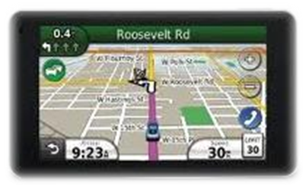

The Parable of the Crew C-H-I-E-F
Christ - Helps - In - Every - Fight
My friend and I snuck into our first “stock car” race when we were 12. We wanted to see our next door neighbor Mutt Grigsby race 50 laps around a dirt track in his homemade gold colored stock car #99. He built, drove, adjusted the engine, and changed his own tires during the race. He even cleaned the mud out of the large round holes that were cut in the body just above the tires that were there to help cool things down. And when he got home, he made all the repairs to the engine and the body himself. I guess you could say he was his own crew chief!

What Mutt Grigsby had to do to prepare and race old #99 every weekend in the late 1950’s in now done by a large group of highly trained professionals known as a “racing team.” There are team members who only change front tires (changing rear tires requires a different skill set don’t you know!), others build engines, and others build frames … I’m told that a few race teams even have a yoga instructor for the pit crew and a nutritionist who oversees their diet!! (I wonder if old Mutt ever did yoga. I digress!).

Most of this increased activity and staffing levels is overseen by a Crew Chief, a modern day orchestra conductor with a torque wrench! The crew chief must keep an eye on many activities that are each important to the success of the team. If just one of his yoga trained, carbohydrate counting tire changers leaves a lug nut loose, the race could be lost. That’s why today’s successful NASCAR Crew Chief is highly sought after and highly paid.

In the spiritual world, before we give our heart to Christ, we are very muck like my former neighbor and his one man show with old #99. We have to do it all … we have no help. And we get very tired trying to win the race of life by ourselves. But when we ask Christ to come into our lives to be our LORD and Savior, we soon learn that this new crew chief brings along a great staff and full load of new tools: The Holy Spirit comes to live within us, and we are outfitted with The Helmet of Salvation, The Shield of Faith, The Breastplate of Righteousness, The Belt of Truth, The Sword of the Spirit, and the Shoes of the Gospel of Peace (Ephesians 6:10-18).

So if you are out there on your own, trying to do it all on your own (even if you do yoga and eat trail mix), ask Christ to be your new Crew CHIEF and see how much better the race of life is when:

Crew C-H-I-E-F

Christ - Helps - In - Every - Fight!

