DRIVING thru the BIBLE

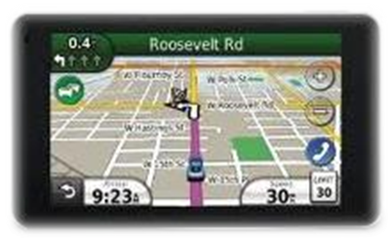

The Parable of the Race Car DECAL

DECAL: Daily - Exhibit - Christ's - Atoning - Love

As the network TV helicopter hovers over the pit area, you can easily see many brightly colored racecar trailers and racecars parked side by side, each one proudly displaying their sponsor’s name. And because sports like NASCAR now have a global advertising reach, each sponsor must pay their respective race team a heavy price for the opportunity to display their product name and logo on a 200 mph billboard that will be seen each week by millions of fans worldwide.

And then there’s merchandizing. Each sponsor also pays to have their company logo or decal placed on other related items … flag pennants, tee-shirts, model cars, window decals, and the ever popular ball cap. In fact, there is so much money involved in merchandizing in the motorsports world today that those who try to offer counterfeit items that represent the real thing are subject to heavy fines and possible prison time.

As Christians, we too are called upon to advertise for our heavenly sponsor; He also paid a heavy price for us to run the race of life while bearing His name. But simply wearing a Christian cross around our neck is not the advertising program He wants us to follow. We are to advertise for Him through our actions … the fruit of the spirit (love, joy, peace, patience, kindness, goodness, faithfulness, gentleness, self-control: Galatians 5:22-23).

So ... how well are you doing for your heavenly sponsor? Try this the next time someone asks you if you are a Christian. Simply say, “What do you think? Do I act like a Christian, or do I act like the counterfeit one who talks the talk but doesn’t walk the walk.” That’s the real test to see if you are a:

D-E-C-A-L for Christ

Daily - Exhibit - Christ’s - Atoning - Love!

And only those around you, especially those who know you best, can tell you if you are the real thing … don’t risk being lost in an eternal prison for being a counterfeit Christian.

