DRIVING thru the BIBLE

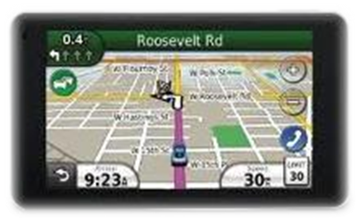

The Parable of the Fire S-U-I-T

Safe - Unafraid - In Control - Trust

If my memory serves, NASCAR “Top 50 Driver” Glenn “Fireball” Roberts died as a result of a fiery crash during a race at Daytona in the early 1960’s. He was wearing a tee shirt at the time, not much protection in a fire. He was pulled from his burning car by fellow drivers, ending up with 2nd and 3rd degree burns over 80 per cent of his body; he died 30 days later. This tragic event hit the tight knit NASCAR community hard. After a thorough investigation was conducted, the firesuit was designed and mandated for wear during racing events to help protect drivers and pit crews from the real danger of fire.

Paul warned the Ephesians in Chapter 6 verse 16 also about the dangers of fire: “above all, taking the shield of faith with which you will be able to quench all the fiery darts of the wicked one.” When we run the race of life without faith in GOD, it’s just like driving a racecar while wearing jeans and a tee shirt. It’s only a matter of time until we crash and burn. NASCAR learned the hard way that a firesuit was needed to help protect racecar drivers and pit crews. We humans also learn the hard way that without faith in GOD, we too expose ourselves to potentially devastating tragedy in our own lives. It’s only when we surrender our life to Christ, and ask Him to send the Holy Spirit to come and live within us, do we finally take off that tee shirt of unbelief and put on the firesuit of faith!

Simply put, when we have faith in GOD, we feel Safe, Unafraid, In Control, and we Trust Him to protect us, just like the fire suit helps protect us during a race!

Fire S-U-I-T

Safe - Unafraid - In Control - Trust

