DRIVING thru the BIBLE

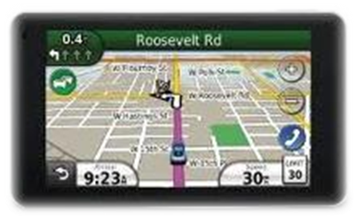

Genesis (Starts)… Revelation (Completes)

Earth Created Gen 1:1
Earth passed away Rev 21:1
Sun to govern the day Gen 1:16
No need of Sun Rev 21:23
Darkness called night Gen 1:5
No night there Rev 22:5
Waters He called the sea Gen 1:10
No more sea Rev 21:1
A river for earths blessing Gen 2:10-14
A river for new earth Rev 22:1, 2
Entrance of Sin Gen 3:6
End of Sin Rev 21:27
Curse pronounced Gen 3:14-17
No more curse Rev 22:3
Death entered creation Gen 3:19
No more death Rev 21:4
Man driven out of Eden Gen 3:24
Man restored Rev 22
Tree of Life guarded Gen 3:24
Access to the tree of life Rev 22:14
Sorrow and suffering enter Gen 3:17
No more sorrow Rev 22:4
Rainbow for a promise Gen 9:13
Rainbow for remembrance Rev 4:3; 10:1
A bride of Abraham’s son Gen 24
A bride for Abraham’s seed Rev 21
Marriage of 1st Adam Gen 2:18-23
Marriage of last Adam Rev 19
Man’s dominion ceased; Satan’s begun Gen 3:24
Satan’s dominion ended; Man’s restored Rev 22

