DRIVING thru the BIBLE

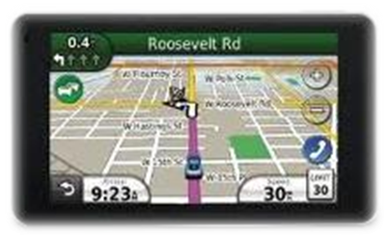

Joseph… as a Type of Christ

Genesis (Joseph) Scriptures (Christ)

37:2 Occupation: Shepherd Ps 23
(as were Abel, Jacob, Moses, David)
37:3 Clothing Distinctive Ps 22:18; Mt 27:35
37:4 Hated by his Brethren (for who he was) Jn 1:11; Jn 5:18; 1 Cor 16:22
37:7 Future Kingship foretold Mt 26:64
37:13 Sent forth by his father 1 Jn 4:10; Heb 10:7
37:17 Joseph was sought until he was found Mt 9:8
37:18 Conspired against Mt 12:14
37:19 Words disbelieved Mt 27:39; Jn 3:18
37:23 Insulted; stripped Mt 27:27
37:24 Cast into jail Zech 9:11; Mt 12:40
37:28 Sold Zech 11:12, 13
(Judah(s) negotiates price) Mt 26:11-16
37:31 Blood presented to his father Heb 9:12, 13
(sin offering) Gen 22
39:7 Heavily tempted, did not sin Lk 4
(in Egypt, the world) 2 Tim 2:22; Ps 105:19
39:16 Falsely accused Mt 16:59, 60
39:19 No defense presented Isa 53:7
39:20 Cast into prison without verdict Jn 18:38
39:20 Suffers though innocent Acts 7:9
39:20 Suffers at the hands of gentiles Acts 4:26
39:21 Won respect of his jailor Lk 23:47
40:1 Numbered with the transgressors (between thieves) Isa 53:12
40:20 Predictions came true Mt 5:18
41:33 Wonderful Counselor Col 2:3
41:40 Seated on another’s throne Rev 3:21
41:45 Has a Gentile wife given to him Rev 19:7-8
41:46 30 years old when he began his work Lk 3:23
41:55 Dispenses the bread of life to the world Acts 4:12; Jn 6:26
42:1 Brethren driven out of their own land Gen 15:13; Deut 26:63
42:6-8 Unknown and unrecognized by his brethren Jn 1:11
(7 years of Jacob’s troubles) Jer 30:7

