DRIVING thru the BIBLE

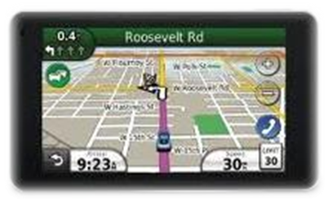

Laws Broken during the Trial of Jesus

- The binding of a prisoner before he was condemned

- Judges participated in the arrest of the accused

- No legal transactions, including trials, could be conducted at night

- A guilty verdict required a majority of two, and was to be pronounced on a subsequent day

- No prisoner could be convicted on his own evidence (Jesus claimed to be God, but that could not be used against Him)

- It was the judge’s duty to see that the interest of the accused was fully protected.

- The use of violence during the trail was apparently unopposed by the judges

- The judges sought false witnesses against the accused

- In a Jewish court the accused was to be assumed innocent until proved guilty by two or more witnesses

- No witness was ever called for the defense

- The court lacked the civil authority to condemn a man to death

- It was illegal to conduct a session of the court on a feast day

- The sentence is finally passed in the palace of the high priest, but the law demanded it to be pronounced in the temple, in the hall of hewn stone

- The high priest rends (tears) his garments. He was never permitted to tear his official robe (Lev 21:10). Without his priestly robe, he could not have put Christ under oath

