DRIVING thru the BIBLE

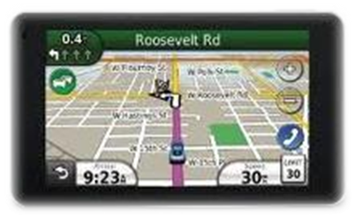

The Parable of the PEDAL

Pushing - Everyday - Doesn't - Advance - Love

You look in your rear view mirror and see an old buddy from high school flashing his headlights and pointing for you to pull over. You pull off the road into the local convenience store parking lot and wait for him to come along side. You roll down your window and wait for him to ask his usual question. Revving his engine and winking his eye, he says, “Hey… you want to drag race out on the old saw mill road?” You say, “Nah… these high gas prices are killing me. You go ahead on out there. I’m sure somebody will take you up on your offer.” He rolls up his window, darts out the parking lot, and squeals rubber through all four gears!

You just laugh and say, “Ah… he’s always in a hurry!” You roll up your window and head on down to the mall to do a little shopping. As you enter the parking lot, two people try to cut you off, and the person behind you is blowing their horn and waving their arms telling you to get a move on. You finally find a parking place and head inside. People are shoulder to shoulder, bumping into one another, not paying a bit of attention to where they walk or whom they bump into with their bags. It looks like a walk-a-thon for some charity. You say to yourself, “This place looks like a zoo! I’ll just go over to the ice cream shop and get a milk shake.” You drive to the ice cream shop and notice that the line is out the door and down the sidewalk! Now what?

All this hustle and bustle reminds me of what my father told me years ago about being in a hurry: “Sonny… Being in a hurry is like rocking in a rocking chair; there’s a lot of activity, but there ain’t a lot progress!” We also put our testimony at risk when we live life in the fast lane. Jesus in Matthew 7:16 and Paul in Galatians 5:22-23 tell us that it is by the fruit of our spirit that others can tell if we are truly believers walking the walk. Running through life with the pedal to the metal very seldom leads to a testimony of patience, kindness, gentleness and self-control.

Once again it’s a matter of balance. In Paul’s last letter as an apostle before being beheaded in Rome, he tells his young friend Timothy in 2nd Timothy 1:7, “For God did not give us a spirit of timidity, but a spirit of power, of love and of self-discipline. We need to be sure that we practice self-discipline when we use the great power of love that God has given us access to when we accept Christ as our Lord and Savior. So the next time you feel the need for speed, be careful not to overuse the:

P-E-D-A-L

Pushing - Everyday - Doesn't - Advance - Love

