DRIVING thru the BIBLE

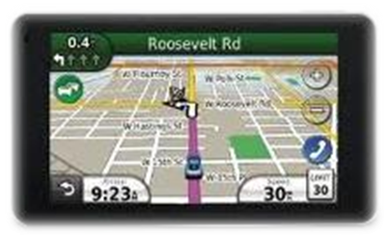

The Parable of the P-I-N-K Slip

Prayer - Invites - a New - King

I’m flipping through the TV channels some time ago and I come across this program on the speed channel called “Pinks.” There’s this guy with a shaved head talking to two guys about the rules of a drag race. I watch the program for a while and start to get the hang of what he’s talking about. There’s going to be a drag race between these two guys, and the winner of the race gets ownership of the other guy’s car… not a trophy, not money… nope… the winner of the race takes ownership of the other guy’s car! He gets the other guy’s “pink slip.”

For many years here in California, the car title was printed on a slip of paper that was pink. And whoever actually owned the car “held” in their possession what was known as the “pink” slip. For example, if you borrowed money to buy a car, the bank held the pink slip until you paid off the loan. Then once the loan was paid off, the bank mailed you the pink slip. So before someone can participate in a drag race on this particular TV program, the car owner must present his or her “pink slip” to the racetrack and agree to turn over ownership of their vehicle to the other racer if the other racer beats them to the finish line.

Well who holds the pink slip for your life? Before we give our heart to Christ, we assume that we carry the pink slip for our life. When we turn 18, we make this grand announcement to anyone who will listen that we are now fully in charge of what we do and where we go. But we run the race of life everyday not realizing that Satan is waiting for us to miss a gear, drop a cylinder, or lose traction and then demand that we turn over the ownership of our life to him at the finish line of life!

But it doesn’t have to be that way. When we say the sinner’s prayer and ask Christ to come into our heart to be our Lord and Savior, we surrender our pink slip to Him. No longer do we have to be afraid while running the race of life. We are an eternal winner and can say what the Apostle Paul wrote to Timothy in 2nd Timothy 4:7,8: “I ran the good race, I finished the race, I kept the faith. Now there is in store for me the crown of righteousness, which the Lord, the righteous Judge, will award to me on that day -- and not only to me, but also to all who have longed for his appearing.” So if you haven’t done so already, give Christ your:

P-I-N-K

Pray (the sinner’s prayer) - and Invite - the New - King!

