DRIVING thru the BIBLE

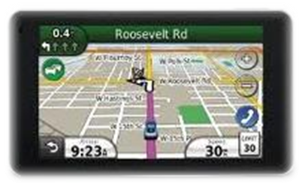

The Parable of the P-O-L-E Position

Prayer - Opens - the Lord’s - Ear

Several days before the start of each NASCAR race, you can see many beautifully painted big rigs arrive in the pit area to unload their race cars for practice, tune up, and time trials. The order in which the cars will start the race will be determined by how well each car performs during time trials. The faster cars will be starting the race ahead of the slower cars. The fastest qualifier for the race will be starting the race on the inside of the front row at the starting line, a starting position known in the racing community as the “pole” position. However, starting a race in the pole position does not automatically give the driver an edge. It just means that the racecar in the pole position today was the fastest car during a few time trial laps run yesterday without any other cars on the track, and in weather and track conditions not necessarily the same as will be the case during the day of the race.

Well race day is here, the anthem has been sung, and the starting flag has been dropped. As the cars enter lap 5 of the scheduled 250 lap race, you notice that a few of the slower cars from time trials two days ago start to move up to the front of the pack, and that a few of the faster cars from time trials two days ago start dropping back. It appears that the setup for the cars with clear skies and 80 degrees two days ago is not the best setup for the cars today with cloud cover and 65 degrees. As the race progresses, each driver talks with the Crew Chief about how the car is responding in certain situations and how best to make adjustments to the car during the next pit stop.

The communication between these two people is crucial. The better they know each other, the better they can communicate what needs to be done. And they get to know each other the best, and how best to communicate with each other, by spending time with one another. The same is true when running the race of life. Conditions change in our spiritual lives daily. That is why it is important that we talk often with our spiritual crew chief about how we are, or should be, responding to changes. We must remember that Christ once was here running the same race so that we would have someone to intercede on our behalf that understands first hand how tough the race really is.

So if someone you know is running the race with no one to talk to or advise them during their race, introduce them to Christ and share with them the importance of prayer. It’s how we stay connected to our crew chief ... and the line is never busy! Then one day they too will be sitting on the:

P-O-L-E

Prayer - Opens - the Lord’s - Ear

