DRIVING thru the BIBLE

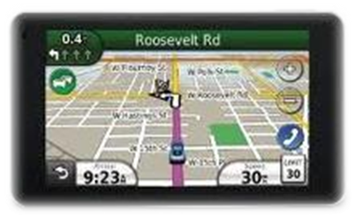

The Parable of the R-A-D-A-R Gun

Remove - Anxiety! Don’t - Accelerate - after Redemption

Well, it’s summertime again, time to head to the beach. You pack up the car, stop for gas, and head down the highway. Your radio is playing loud… everyone’s talking and laughing. About three miles into the journey, you look out the corner of your eye and notice a motorcycle officer with a radar gun pointed right at you. You quickly look down at the speedometer and gasp… 70 mph in a 55 mph zone.

Out from behind the trees you see the motorcycle officer quickly enter the roadway and turn on his lights and siren. You know what’s coming. You pull over to the side of the road and wait for the news… “Do you know why I pulled you over, sir?” says the officer. “You were exceeding the speed limit.” He quickly checks your driving history and sees that you have a clean driving record. The officer then reminds you that even though you deserve to pay a fine, he has decided to give you a warning ticket and asks you to slow down and obey the speed limit. You let out a sigh of relief that you didn’t have to pay a fine “and” you notice that you pay more attention to your speed (at least for a while!).

When we exceed the speed limit in our spiritual life, the Holy Spirit, our internal radar gun, pulls us over and reminds us that Christ paid the fine for our sins “and” that we are to pay more attention to our actions on the spiritual road of life. It is at that moment that we should feel the same level of spiritual relief that we do when an officer of the law lets us off with a warning ticket. Paul tells us in Romans 6:1-6 that God’s grace covers all our sins, even the sins we commit after being saved. However, salvation does not give us the liberty to keep on sinning just because we are under GOD’s grace. He is still watching us with HIS heavenly radar system! So remember:

R-A-D-A-R

“Remove - Anxiety (ask for forgiveness)! - and Don’t - Accelerate - after Redemption

