DRIVING thru the BIBLE

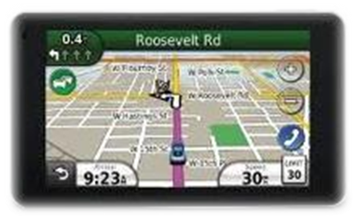

The Parable of Gear R-A-T-I-O

Redemption - Alters - Thoughts - Inside – Out

There are many rotating components within an automobile that operate at different speeds. For example, the automobile engine rotates much faster than does the rear axle. The little motor that raises and lowers your car windows turns at a higher speed than does the speed of the window opening and closing. And finally, each gear within a four speed manual transmission rotates at a different speed so as to deliver the appropriate power to the drive shaft during acceleration and deceleration.

In each of these examples, there is a group of large and small diameter gears that are connected in such a way as to allow two shafts to rotate at different speeds and still be connected to one another. This is achieved by connecting two gears that have different diameters. It is this difference in the diameters of the gear that is doing the driving (the powered gear), compared to the diameter of the gear that is being driven (the driven gear), that is known as the gear “ratio.”

Before someone accepts Christ to be their Lord and Savior, the “ratio” of the things they do for themselves, compared to the number of things that are done for others, is probably very high. This is because a very large diameter gear known as the flesh is the power source that powers all the activity for the selfish person. The “flesh” gear assembly does it’s dirty work by powering three smaller gears known as me, mine, and now! The flesh powered gear assembly must run at full speed all the time to ensure that it receives constant lubrication by acquiring more “stuff” and more “praise” than any other gear assembly that it competes with. And it is this constant high-speed operation under great stress that eventually causes catastrophic failure to any gear assembly powered by the flesh.

Fortunately there is a drive gear assembly available for the asking that helps us prevent eternal catastrophic failure … The Holy Spirit. When we ask Christ to become our Lord and Savior, the Holy Spirit brings along a new set of smaller gears that will slow the system down. The smaller gears are: love, joy, peace, patience, goodness, faithfulness, gentleness, and self-control. With this new gear assembly in place, we no longer have a need to run wide open and risk eternal damage. As Paul tells us, “if anyone is in Christ, he is a new creation; the old (ratio) has gone, the new (ratio) has come (2nd Corinthians 5:17, emphasis mine).

So get in “gear” and ask Christ for a new power source. You’ll be amazed at how smooth your life will be when you operate at the right:

R-A-T-I-O

Redemption - Alters - Thoughts - Inside - Out!

