DRIVING thru the BIBLE

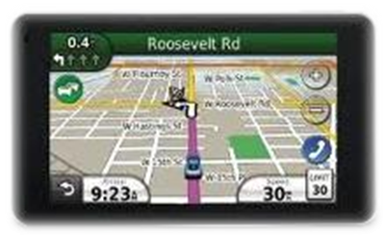

Devil’s Schemes God’s Plan Bible Reference

“My power” “God’s power Eph 3:16

Lies Truth Proverbs 14:25

Fear Love 1 John 4:18

Discouragement Confidence, Strength Deut 31:8

Anger Patience 2 Timothy 2:24

Powered by alcohol Powered by The Holy Spirit Ephesians 5:18

Complaining Contentment Phil 2:14

Death Life John 5:24

Gossip Confidentiality Proverbs 20:19

Regret and shame God’s forgiveness Acts 3:19

Greed Giving Luke 12:15-21

Cursing your enemies Blessing your enemies Luke 6:28

Revenge Forgiveness Matt 6:14-15

Hateful Talk Encouragement Eph 4:29

Self-pity Songs of praise Eph 5:19-20

Laziness Productivity, watchfulness Proverbs 12:24

Unfaithfulness Loyalty Phil 2:4

Irresponsibility Dependability Proverbs 14:14

Being Rude Being considerate Titus 3:2

Worry Rest Matt 11:28-29

Anxiety Peace John 16:33

Jealousy, envy Abundant heart James 3:16-17

Using others Sacrificing for others 1 Cor 13:4-7

Rage Self-Control Col 3:8-12

Sexual immorality Sexual fidelity 1 Thess 4:3

