DRIVING thru the BIBLE

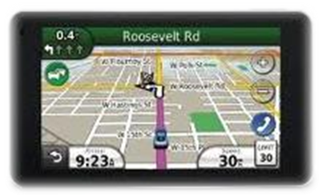

Seven Contrasts in the Epistle of 1st John

7 Tests of Truth vs. Error

1. Contrast of Beliefs
Light vs. Darkness 1st John 1:5 - 2:11

2. Contrast of Desires
Father vs. World 1st John 2:12 – 2:17

3. Contrast of Doctrines
Christ vs. Antichrist 1st John 2:18 - 2:28

4. Contrast of Conduct
Good Works vs. Evil Works 1st John 2:29 - 3:24

5. Contrast of Discernment
Holy Spirit vs. Error 1st John 4:1 - 4:6

6. Contrast of Motives
Love vs. Pious Hypocrisy 1st John 4:7 - 4:21

7. Contrasts of New Birth
The God-Born vs. others 1st John 5:1 - 5:21

